Set up a VPC with an Internet gateway, create a public subnet, a private subnet make a route table connecting the Internet gateway and the subnets, and launch a Linux EC2 instance by using the above vpc and public subnet.

**Solution:-**

Creating a VPC(Name is my-vpc)

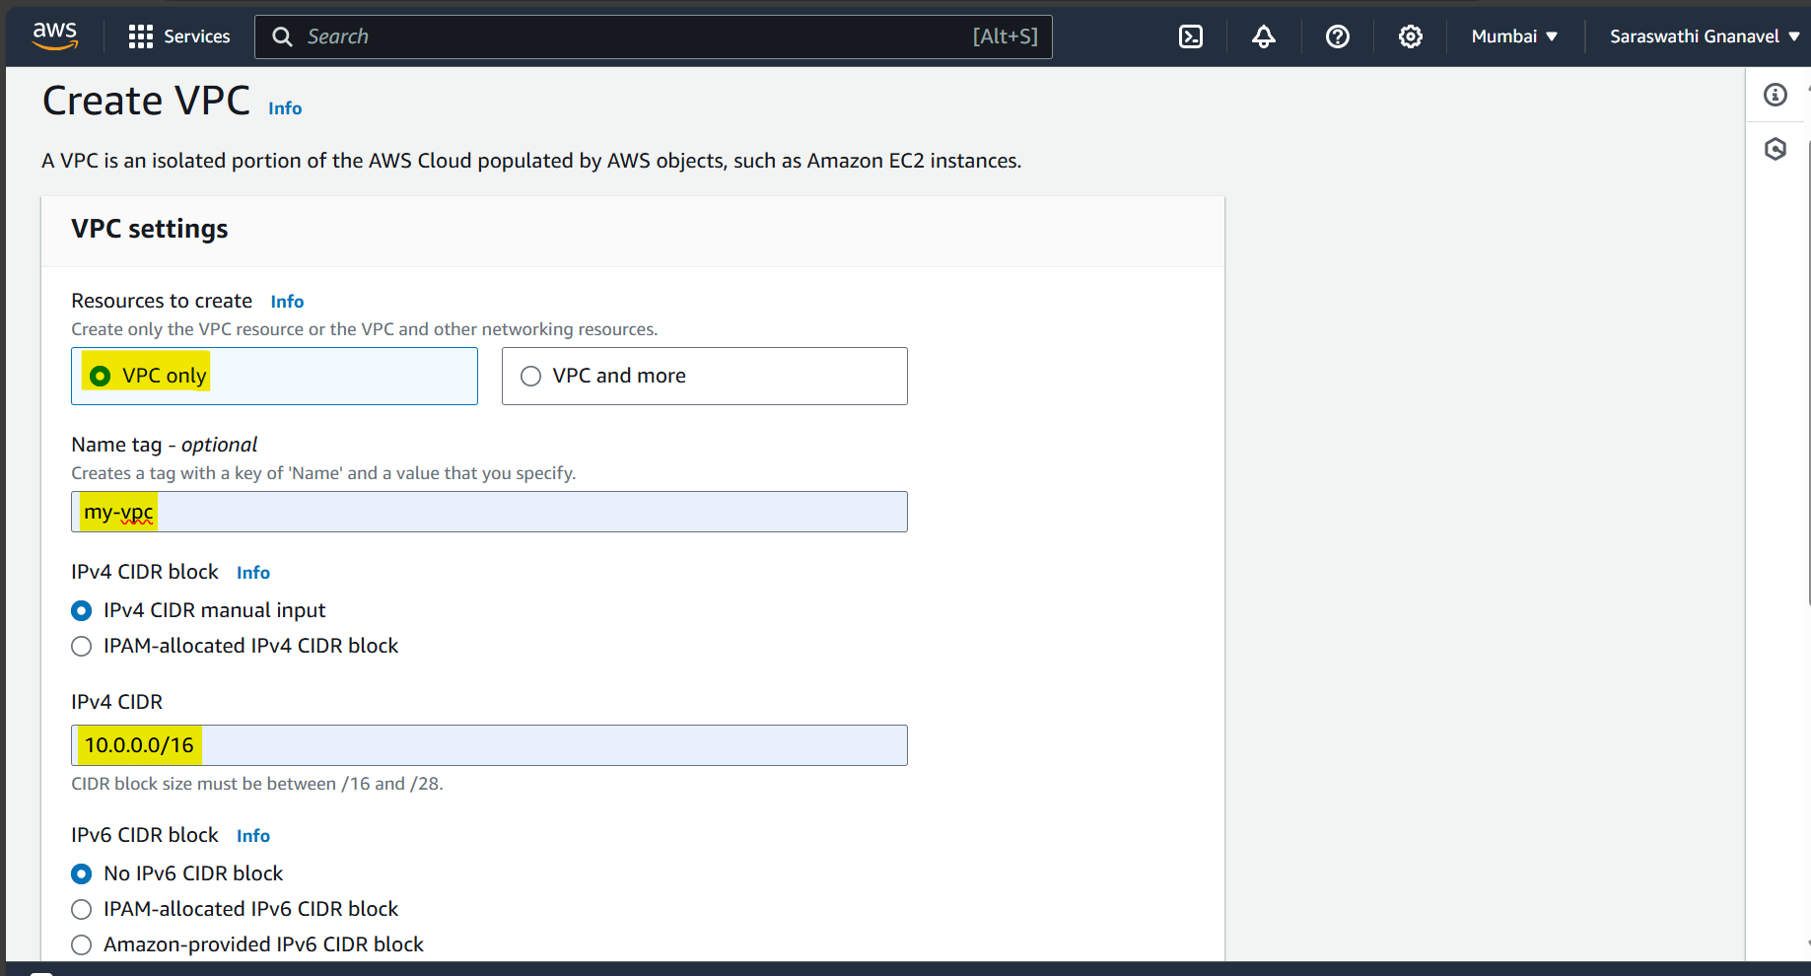

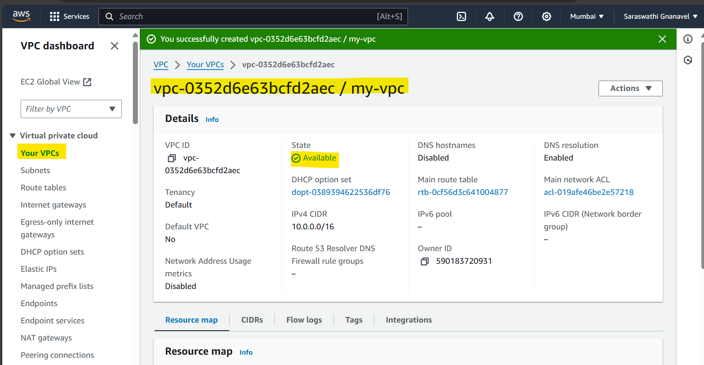

Creating Subnets (named as my-subnet)

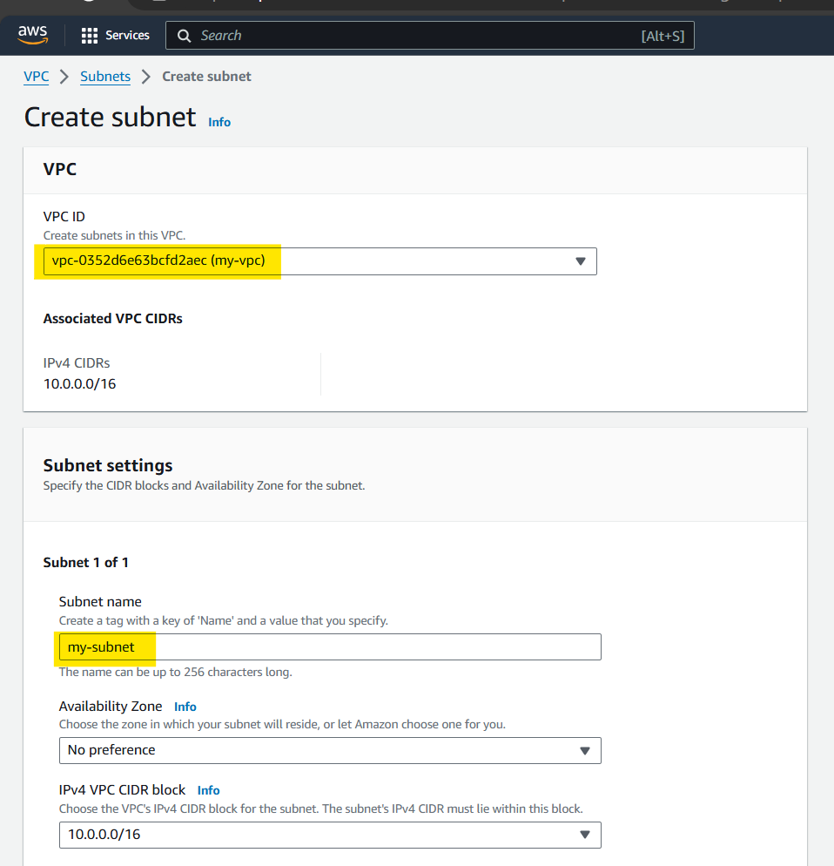

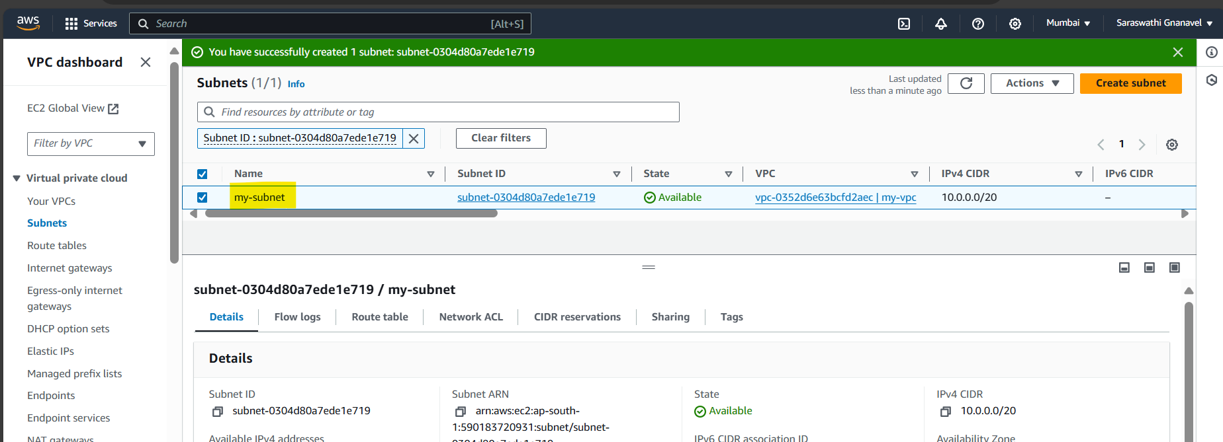

Creating an Internet Gateway(named as my-internet-gateway)

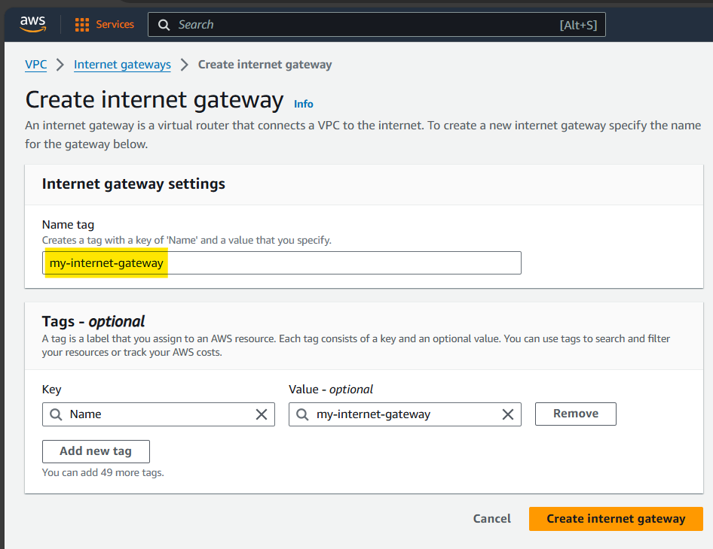

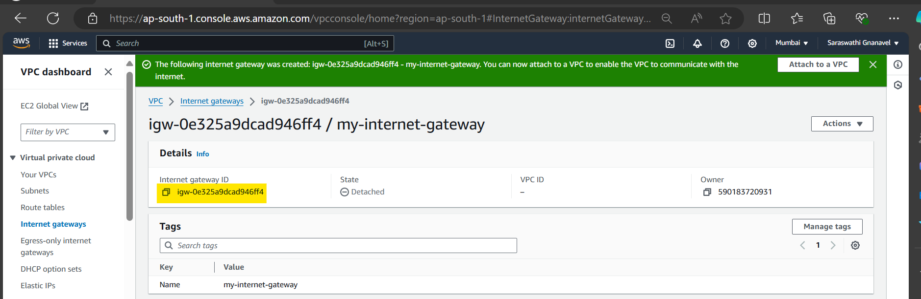

Attaching my-vpc with my-internet-gateway

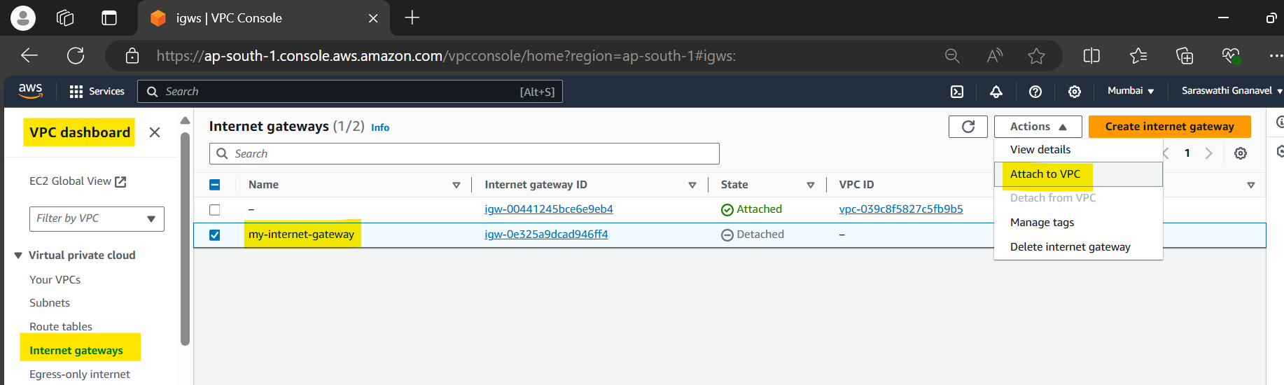

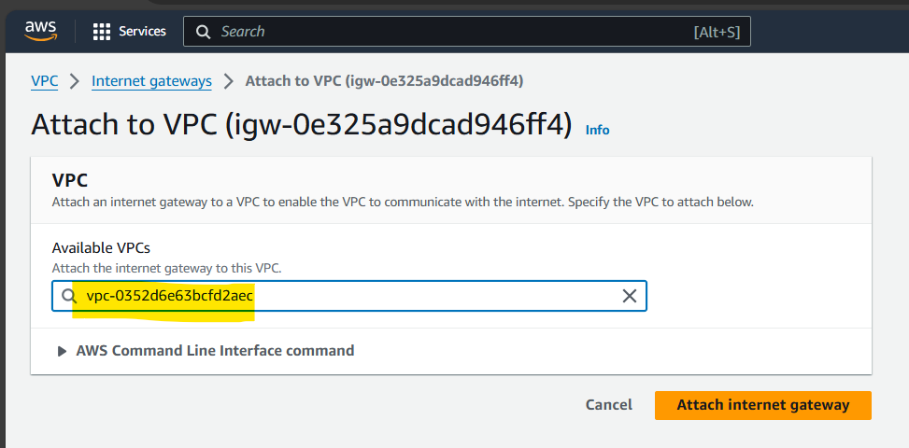

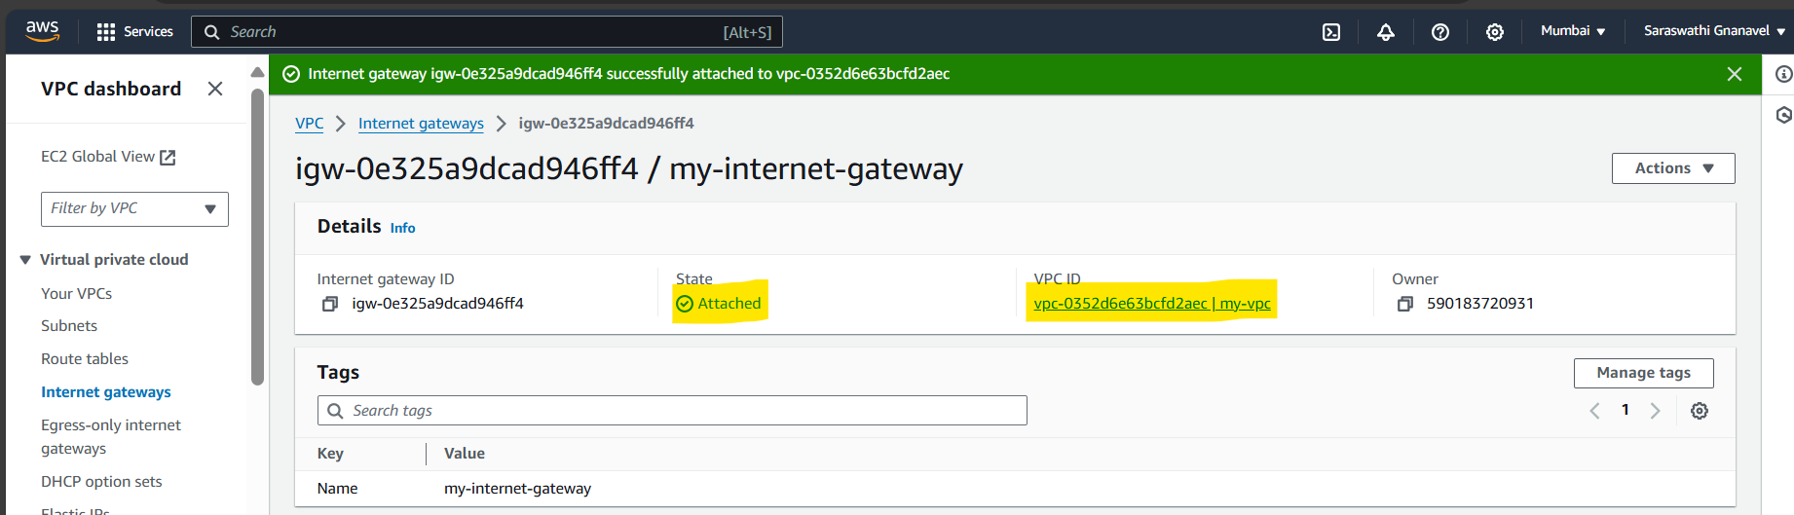

Creating and Configuring Route Tables(Named as my-route-table)

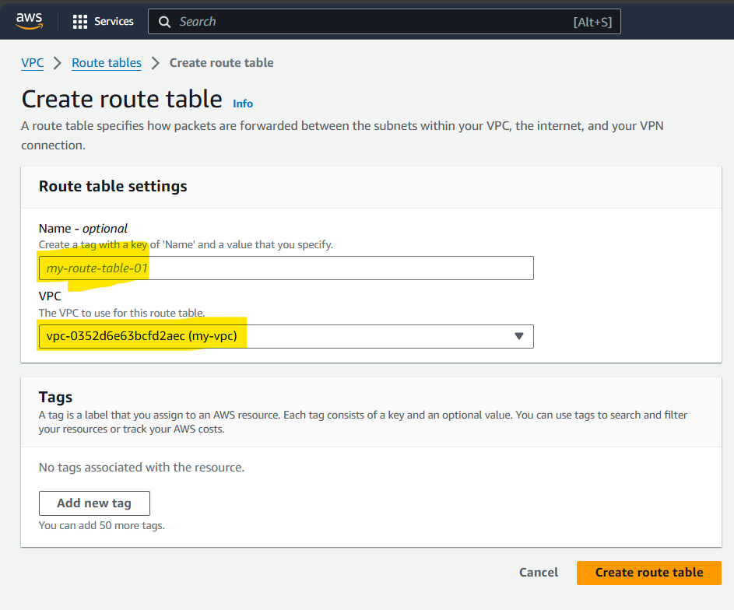

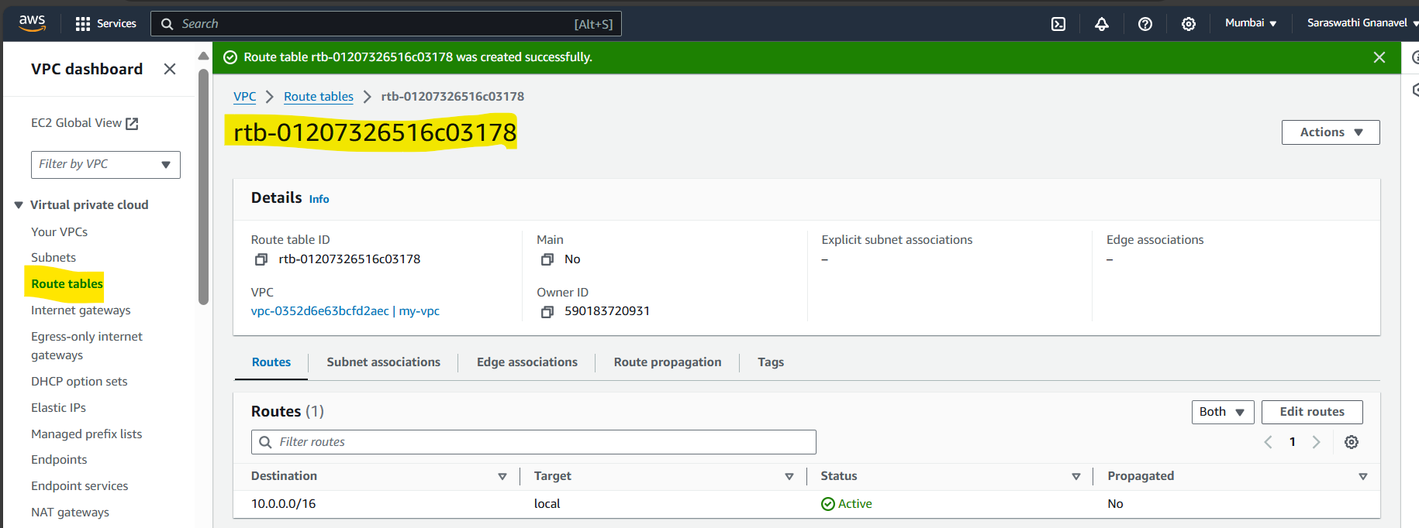

Editing Routes for the Route Table

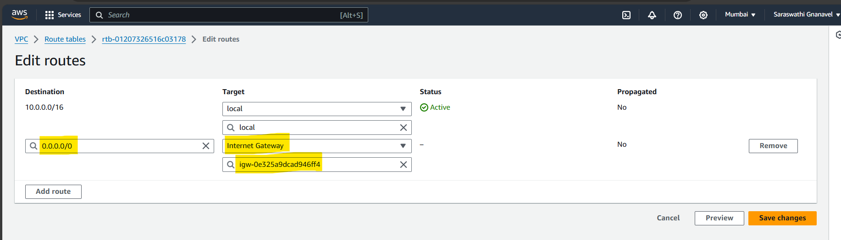

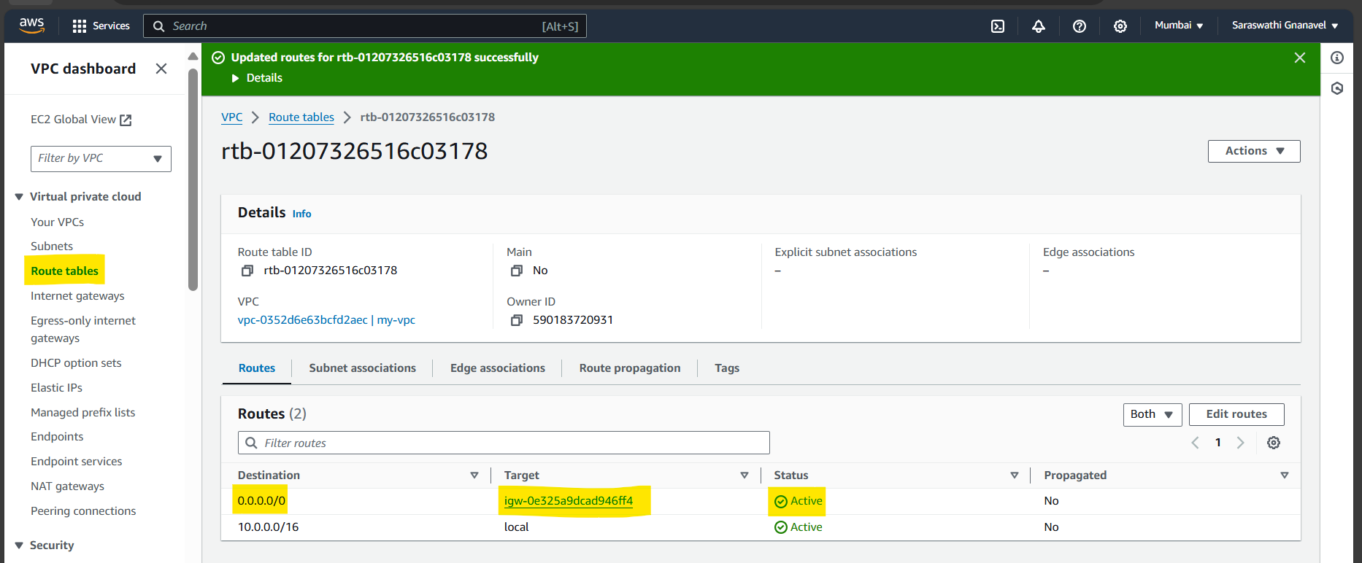

Launching an ubuntu EC2 Instance(Named as test)

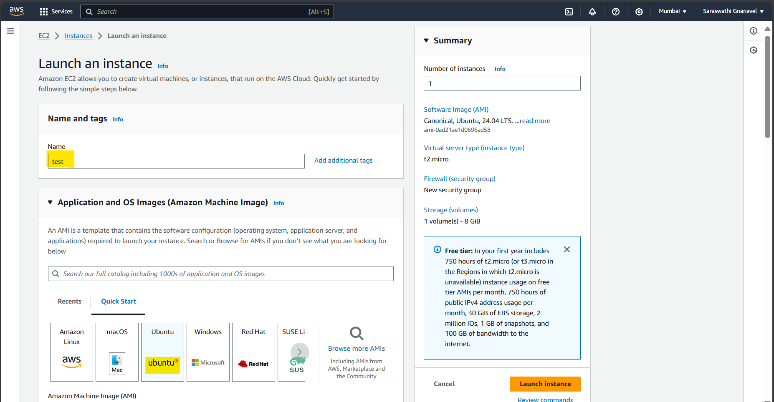

Configuring VPC(my-vpc) with subnet(my-subnet)

